Project Title: It’s Not Football, It’s La Liga: An Analysis of Team Tactics, Player Progression and Transfer Strategies

Name : Abhishek Adhikary

TABLE OF CONTENTS

1. Introduction
2. Design Process
3. Implementation
4. Technical Implementation
5. Interactive Narrative Visualisation Implementation
6. Using the Implementation
7. Conclusion
8. Bibliography
9. Appendix

Introduction

Problem Description:

The Project on La Liga sports analytics, deep diving into various aspects of one of the world's premier football leagues, known for competitive matches and extraordinary player talent. The league's rich history of tactical innovation and its impact on global football culture present me a unique opportunity to apply sports analytics. I would like to review the underlying game trends, player performance metrics, and the Transfer Market to get findings that would be useful in the development of coaching strategies, player development programs, and ways through which the fans' experience can be improved using data. It gives a perspective that will allow the analysis of patterns of play, individual contribution of players, and strategies of the team that gives a full scope of the competitive landscape within La Liga.

Aims:

• To Analyse Team Tactics : The project aims to uncover the underlying game trends and tactical innovations that have impacted La Liga and global football culture on the whole.

• To Study Player Progression : By reviewing player performance metrics, the project intends to provide insights that could enhance player development programs.

• To Examine Transfer Strategies : The analysis aims to understand the dynamics of the Transfer Market, evaluating how well teams manage their investments.

• To Get the Fans and General Public more into La Liga through a Data Driven Approach.

Motivation:

• Personal Passion : The motivation comes from a lifelong interest in football, making this analytical attempt a project out of passion to allow people to take interest in it as well.

• Data-Driven Insights :There is a clear intent to use data visualizations to gain insights into team performances, player contributions, and transfer market trends, which can help improve general fan experiences and strategic planning within clubs.

• Impact on Football Culture :The project is seen as an opportunity to contribute to the broader football culture by providing a data-driven perspective on one of its most followed leagues.

Indented Audience:

The target audience for this project includes football enthusiasts, sports analysts, coaches, and club management professionals who have a keen interest in La Liga and the La Liga Teams and their tactics, player development, and transfer market dynamics. Additionally, the project aims to engage data science and sports analytics practitioners who are interested in applying their skills to real-world football scenarios. By offering data-driven insights, the project also seeks to captivate fans and the general public, enhancing their understanding and enjoyment of the game. Ultimately, this project aims to bridge the gap between technical analysis and accessible football narratives, making it valuable for both professional stakeholders and passionate supporters of the sport.

Design Process

The Narrative Visualisation here has a clear aim, that is to provide a comprehensive analysis of various aspects of La Liga, including team performance, player metrics, and transfer market dynamics. It involved a structured approach to effectively convey insights. The aim was mainly to convey the data-driven insights in a story like format to which the general public and football enthusiasts and the technical stakeholders could relate to. Great level of attention is paid to bridge the gap between technical analysis and accessible football narratives.

The Visualisations and the Designs tie back to the Data Exploration Project where we delved deep into the Data Pre-Processing and Data Wrangling. Some Datasets were added after the DEP and the final designs, and the Dashboard was arrived at based on the constructive feedback received.

The design process was informed by Munzner's what-why-how framework and followed the Five Design-Sheet (5dS) methodology. The implementation was carried out using R and Shiny, leveraging various visualization libraries to create an engaging and informative dashboard.

The design process for this project adhered to the Five Design-Sheet (5dS) methodology. This method emphasizes generating, exploring, and evaluating a broad range of design solutions. The five design sheets facilitate brainstorming ideas, developing initial designs, and finalizing the optimal design. This section will delve into each design sheet and justify the design choices based on theoretical content from the unit, including aspects from Munzner’s what-why-how framework, consistency in design and interaction, colour palette, layout, typography, visual variables, and the human visual system.

I Had Planned on Making five tabs for the Data Visualisation Project:

1. Introduction  
2. Teams Performance Dashboard: Team Performance over the Years and in Seasons.

3. Player Performance Dashboard: In-Depth Analysis of the Players.

4. Transfers Dashboard: Spending of the Clubs and Details of Top 3 Spenders.

5. Conclusion

I have made the Initial Designs and the Final Design based on the Tab 2 (Teams Performance Dashboard) and I have mentioned that at the end of the Brainstorming Sheet at the end of it.  
  
Throughout the design process, the specific needs and interests of the target audience were central to every decision. Understanding that football enthusiasts, sports analysts, coaches, club management professionals, and data science practitioners all have unique perspectives, the visualizations were crafted to be both technically robust and easily interpretable. For instance, detailed performance metrics were presented in a way that allows analysts and coaches to derive actionable insights, while narrative-driven elements and intuitive dashboards cater to casual fans and the general public. This dual approach ensures that the visualizations are engaging and informative, providing value to both technical stakeholders and passionate supporters. By integrating feedback and focusing on user experience, the designs effectively bridge the gap between complex data analysis and accessible storytelling, making the insights not only comprehensible but also compelling for a diverse audience.  
  
Now, here is the Sheet 1 explained first. This sheet (Brainstorming) was crucial for generating a diverse set of ideas and refining them into viable design solutions and this was used to start the entire Design Process.

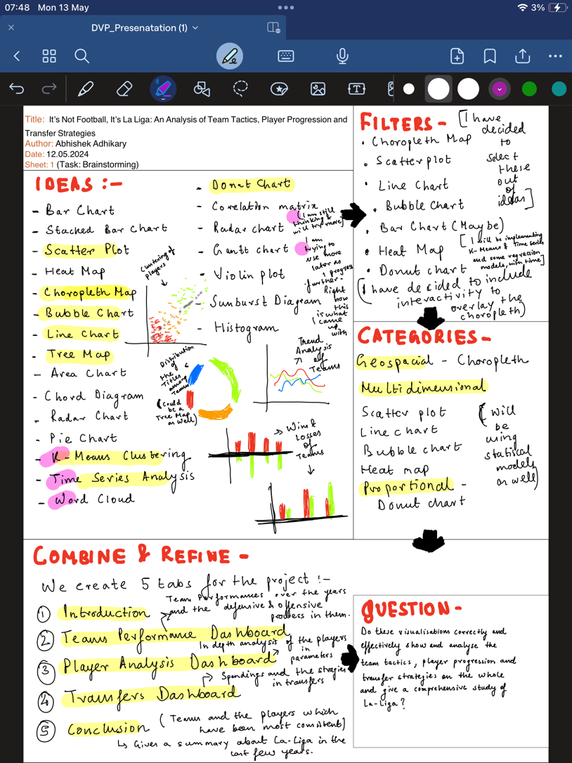The main steps involved in this sheet were:

Generating Ideas : Listing concepts such as different chart types (bar charts, scatter plots, line graphs, bubble charts, Maps, etc) and colour schemes.

For instance, ideas like heatmaps or scatter plots for player performance, timeline visualizations (Bar Charts) for transfer activities, and geographic maps for stadium locations were considered among the many initial ideas to begin with.

Filtering Ideas and Categorizing Ideas: Removing duplicates and infeasible concepts, focusing on ideas that align with the project’s goals like a map for stadiums, and maybe a comparison of Teams Bar Graph. Then grouping ideas based on their applicability to different data types and functionalities. For example, visualizations suitable for temporal data, spatial data, and comparative analysis were grouped accordingly for better understanding of the visualisations.

Figure 2.1: Sheet 1 (Brainstorming)

Combining & Refining: The ideas were combined into coherent combinations that could be developed into comprehensive visualizations. For instance, combining bar charts with line graphs for team performance analysis and integrating scatter plots with bubble charts for player performance metrics. Thus, the Idea of Creating 5 Different Tabs came up for describing each aspect in a comprehensive way. In the next sheets, I have described building the Team Dashboard due to space constraint issues.

Throughout the design phase, a key principle was the consistent use of design elements. For example, colour palettes were selected not only for their visual appeal but also for their ease of cognitive processing like Green for positive and Red for negative. Research into human visual perception reveals that certain colour combinations are easier to differentiate and understand. Additionally, interactive features like sliders and filters will be wherever possible to make users active participants in the narrative rather than passive viewers.

In summary, the design choices in this and the subsequent sheets were deliberate. Whether it was about maintaining visual consistency, selecting colours, or choosing the narration styles, each decision was aimed at creating an engaging, informative as well as an intuitive narrative.

For understanding the design and evaluation of data visualisations we followed Munzer’s What-Why-How framework .

* **What** is the kind of data to be visualised?
* **Why** is the data being visualised–what task does the user wish to perform?
* **How** is the data visually represented and what interaction is provided

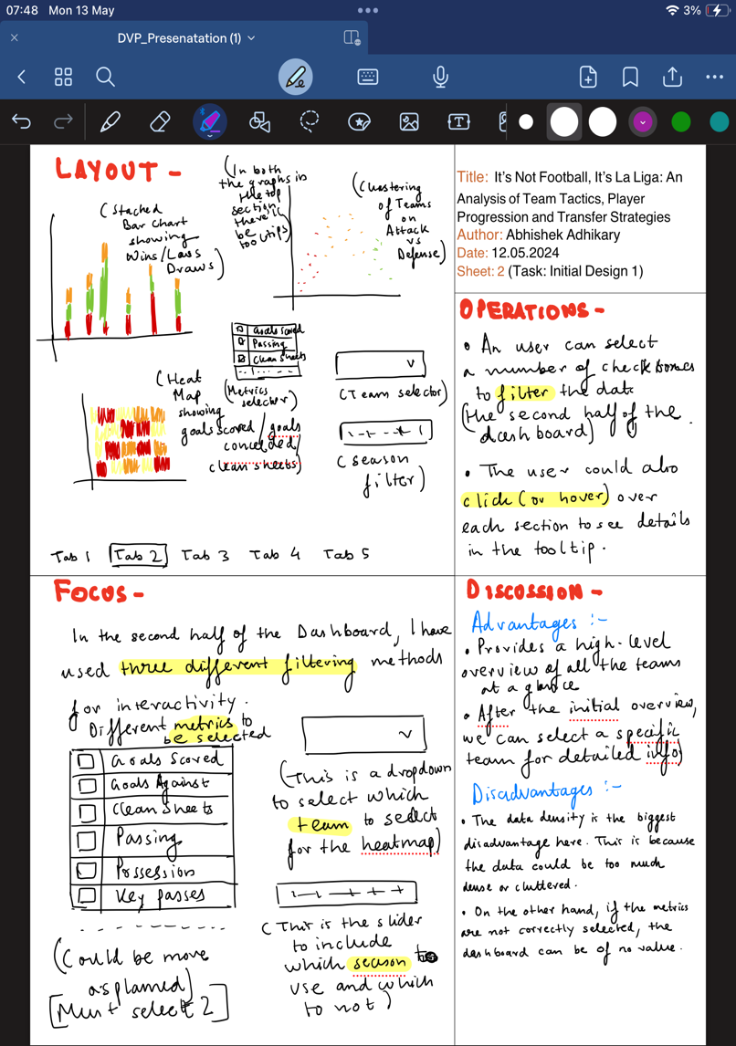From the second sheet (Initial Design 1) we focus mainly on building the Team Performance Dashboard.

It is ensured that there is a consistent use of colours (e.g., green for wins, red for losses, orange for draws) and interactive elements ensures a cohesive user experience. Dropdowns, checkboxes, and hover tooltips provide intuitive interactions, making it easy for users to navigate and explore the data.

The layout is designed to facilitate an overall overview of the teams and an easy comparison of team performance metrics, with clear labels and logical organization. Typography is chosen to ensure readability and clarity, supporting effective data communication. The use of position, size, and colour as visual variables helps in representing quantitative and categorical data effectively. For instance, the scatter plot uses position to represent attack and defence metrics, while the bar charts use colour to distinguish between different performance outcomes.

Figure 2.2: Sheet 2 (Initial Design 1)

The layout includes stacked bar charts showing wins, losses, and draws for different teams. This allows for a clear overview of team performance across various seasons. Additionally, a scatter plot is used to show the clustering of teams based on attack versus defence metrics. Also, the Heat Map allows quite a complex way of comparing two teams and multiple metrics in details. (which could be too much to dig up at a time)

The focus is on providing multiple filtering methods to allow users to interactively explore different metrics and gain insights into team performance. This includes a metrics selector, a team selector, and a season filter and adds up to the narrative style of the 'Interactive Slideshow' which enhances user engagement and understanding.

This aligns with the **Munzner’s What-Why-How Framework** about what are the types of data used (tabular) why the filters and the charts are used and how the visual encoding enhances the user interaction and engagement.

The advantages of this design include providing a high-level overview of all teams at a glance and allowing for detailed analysis of specific teams. However, potential disadvantages include data density, which could lead to cluttered visuals, and the risk of selecting irrelevant metrics.

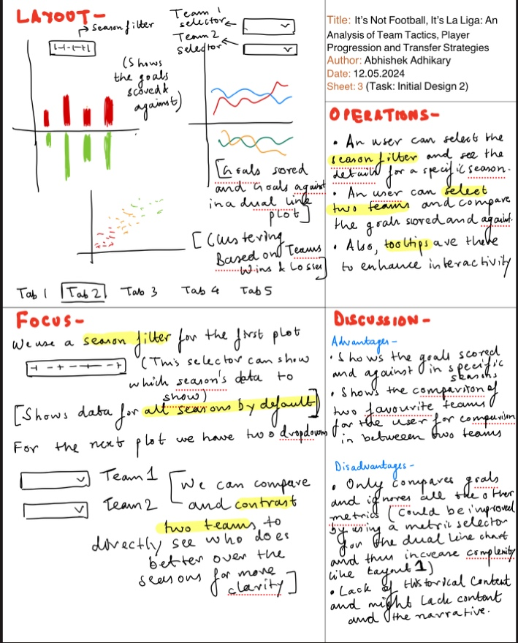Now, the third sheet (Initial Design 2) focuses on enhancing the interactivity and comparative analysis of team performance metrics in La Liga. This design iteration is aimed at providing users with the ability to filter data by season, select specific teams for comparison, and gain deeper insights into team dynamics through detailed visualizations.

Figure 2.3: Sheet 3(Initial Design 2)

The operations in this design are cantered around user interactivity and enhancing the exploration of data

The layout of the dashboard includes three primary components:

Season Filter: This allows users to focus on time frames and observe trends and changes over different seasons.

Team Selector: This comparative analysis helps users understand how teams perform relative to each other.

Visual Representations:

Bar Chart: This visualization provides a clear comparison of team performance in terms of offensive and defensive metrics.

Dual Line Plot: This helps in identifying trends and patterns in team performance across multiple seasons.

Scatter Plot: This visualization provides an overview of team performance and helps in identifying standout teams.

Consistent use of interactive elements such as dropdowns and sliders ensure a seamless user experience. The design maintains a coherent visual style, making it easy for users to navigate and understand. The colour palette is chosen to clearly differentiate between different metrics which is kept similar throughout all the sheets.

Position, size, and colour are used as visual variables to represent quantitative and categorical data effectively. For instance, the dual line plot uses position to represent goals scored and conceded over time.

**Munzner’s What-Why-How Framework is followed too**:

**What**: The data includes tabular data (team performance metrics).

**Why**: The tasks include comparing teams, identifying trends, and discovering insights into team performance through interactive filtering and detailed comparisons.

**How**: The visual encoding includes bar charts and line plots, while interactive elements like sliders and dropdowns enhance user interaction.

The design provides a detailed comparison of goals scored and conceded for specific seasons and teams. This helps users understand team performance in a granular manner. However, the design might lack historical context and narrative. Providing historical comparisons and storytelling elements could enhance the overall impact of the visualization.

Now, the fourth sheet (Initial Design 3) focuses on incorporating geographical data and time-series analysis to provide a comprehensive view of team performance in La Liga. This design aims to enhance user understanding through spatial visualizations and trend analysis over multiple seasons. 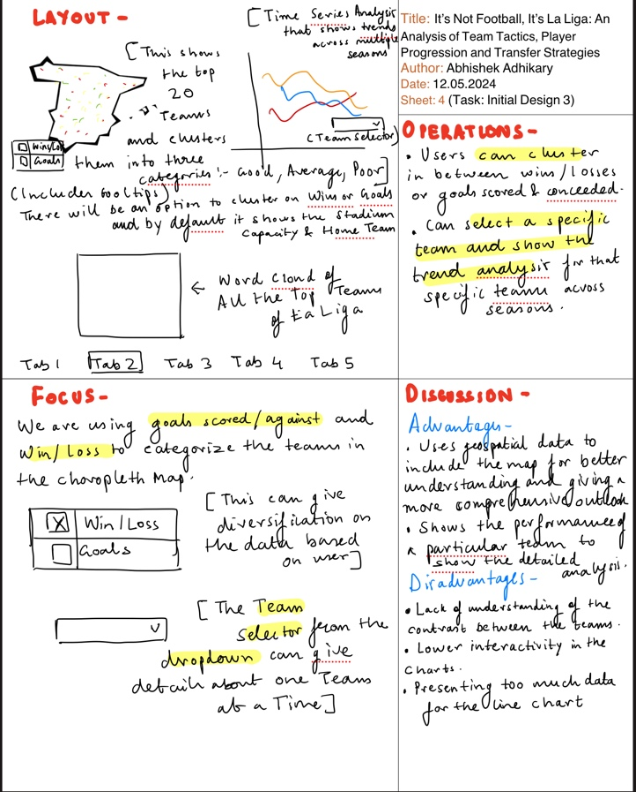

Figure 2.4: Sheet 4 (Initial Design 3)

The focus of this design is to provide a detailed, interactive exploration of team performance with a geographical and temporal context:

Categorization: Teams are categorized based on performance metrics (wins/losses, goals scored/conceded) on the choropleth map using shape file. This allows users to see the geographical distribution of team performance.

Team-Specific Analysis: The team selector dropdown enables users to focus on specific teams and analyse their performance trends over time.

The operations enhance user interactivity and data exploration:

**Clustering Options**: Users can cluster teams based on wins/losses or goals scored/conceded, allowing for a customized view of team performance.

**Team Selection**: Users can select specific teams from the dropdown to view detailed trend analysis across multiple seasons. This enables focused analysis on individual teams.

**Tooltips**: Provide additional information on the choropleth map, enhancing user understanding without cluttering the visualizations.  
The choropleth map introduces a fresh perspective, one that wasn't looked at into in the previous sheets. This could provide newer and fresher perspective on how the Teams have performed across Spain.

Consistent use of interactive elements like dropdowns and tooltips ensures a seamless user experience. The design maintains a coherent visual style, aiding in user navigation and comprehension. The colour palette is chosen to differentiate between performance categories (good, average, poor) and metrics (wins/losses, goals scored/conceded), helping users quickly interpret the data.

Layout and Typography: The layout is designed to facilitate spatial and temporal analysis. Clear labels and logical organization support effective data communication.

Position, size, and colour are used as visual variables to represent quantitative and categorical data effectively. For instance, the choropleth map uses colour to represent different performance categories.

**Munzner’s What-Why-How Framework** is followed as follows:

**What**: The data includes spatial data (team locations) and temporal data (seasonal performance).

**Why**: The tasks include comparing teams, identifying trends, and discovering insights into team performance. The design supports these tasks through interactive filtering and detailed visualizations.

**How**: The visual encoding includes choropleth maps and line charts, while interactive elements like dropdowns and tooltips enhance user interaction.

The design combines exploratory and explanatory visualization styles. It allows users to explore the data interactively while providing clear explanations through tooltips and detailed views.

It offers a holistic view of how teams perform across different regions. While the design allows for detailed analysis of individual teams, it might lack a comprehensive comparative analysis between teams.

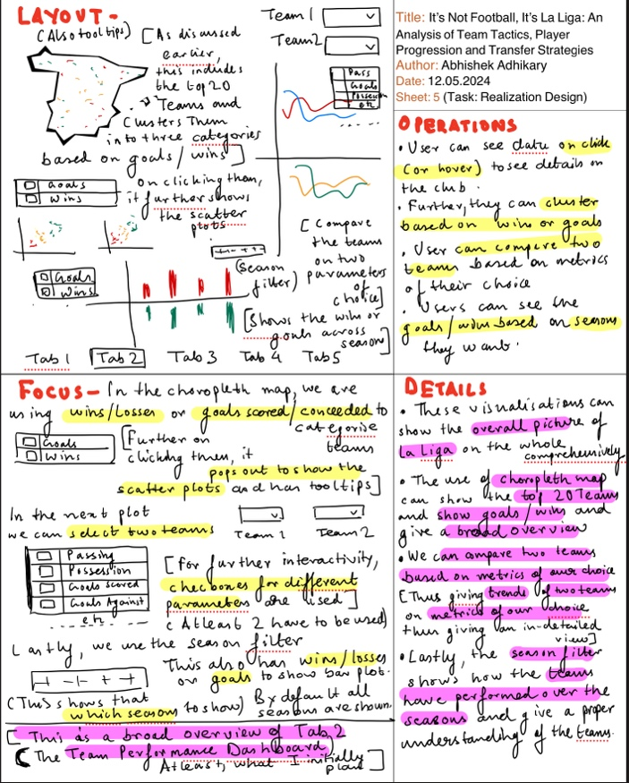

Figure 2.4: Sheet 5(Realization Design)

The final design sheet focuses on providing a comprehensive, interactive, and user-friendly visualization for analysing the teams and the team tactics La Liga. The design integrates previous elements and adds enhanced interactivity and details to create an effective narrative visualization.   
  
It integrates the various initial designs presented in the previous sheets. It functions not only as a summary of the narrative but also as an independent piece that offers a comprehensive understanding of the Teams in La Liga.

The focus of this design is to provide a comprehensive overview and detailed analysis of team performance with high interactivity:

**Categorization and Clustering**: The choropleth map categorizes teams based on wins/losses or goals scored/conceded, providing a geographical and performance-based overview.

**Detailed Comparison**: The dual-axis line plot allows for detailed comparison between two teams, providing insights into their relative performance.

**Seasonal Analysis**: The bar charts with season filters provide an overview of performance across different seasons, highlighting trends and changes over time.

The operations designed to enhance user interactivity include:

**Data on Click (or Hover)**: Users can click or hover over elements on the choropleth map to see detailed scatter plots and tooltips, providing a more in-depth view of the data.

**Clustering Options**: Users can cluster teams based on wins or goals, allowing for customized views and better comparative analysis.

**Team Comparison**: Users can select two teams and compare their performance based on various metrics using the dual-axis line plot.

**Season Filtering**: Users can filter data by seasons to see trends and performance changes over time.

The design choices are rooted in several theoretical principles:

**Consistency in Design and Interaction**: Consistent use of interactive elements (e.g., dropdowns, sliders) and tooltips ensures a smooth user experience. The design maintains a coherent visual style, aiding in navigation and comprehension in all the sheets.

**Colour Palette**: The colour palette is chosen to differentiate between performance categories (e.g., good, average, poor) and metrics (e.g., passing, goals scored), helping users quickly interpret the data.

**Layout and Typography**: The layout is designed to facilitate both spatial and temporal analysis, with clear labels and logical organization supporting effective data communication.

**Visual Variables**: Position, size, and colour are used as visual variables to effectively represent quantitative and categorical data. For example, the choropleth map uses colour to represent different performance categories.

**Munzner’s What-Why-How Framework**:

**What**: The data includes spatial data (team locations) and temporal data (seasonal performance) and includes tabular data (team performance metrics) to include a few.

**Why**: The tasks include comparing teams, identifying trends, and discovering insights into team performance. The design supports these tasks through interactive filtering and detailed visualizations.

**How**: The visual encoding includes choropleth maps, line charts, and bar charts, while interactive elements like dropdowns and sliders enhance user interaction in all the pages.

**Genres of Narration Style**: The design combines exploratory and explanatory visualization styles. It allows users to explore the data interactively while providing clear explanations through tooltips and detailed views.  
  
The use of choropleth maps, interactive plots, and detailed filtering options ensures that the visualization is user-friendly and capable of delivering meaningful insights. This approach aligns with the theoretical principles of data visualization design, ensuring an effective and engaging user experience.

Implementation

Technical Implementation

Several R Packages are used to create an interactive dashboard consisting of visualisations to properly explain the Dynamics of La Liga.

* **shiny**: For creating the interactive web application.
* **shinydashboard**: For structuring the dashboard layout.
* **dplyr**: For data manipulation.
* **ggplot2**: For creating visualizations.
* **plotly**: For making the visualizations interactive.
* **leaflet**: For the geographic map visualization.
* **sf**: For handling spatial data.
* **lubridate**: For working with dates and times.
* **readr**: For reading rectangular data like CSV files.
* **tidyr**: For tidying data, making it easier to work with.
* **stringr**: For simplifying string operations.
* **ggrepel**: For adding non-overlapping text labels in ggplot2.
* **shinyjs**: For adding JavaScript functionalities to Shiny apps.

There were no such external code sources such as templates used. The shinydashboard library was used to design the Dashboard and custom CSS was implemented to format the header and sidebar and the UI was customised to separate the graphs from one another using div tags.

The final design closely matches the mock-ups outlined in the design sheets, though minor differences may be present due to practical constraints or insights gained during the development process. The dual Line Plot and the Bar Graph has been changed into a comparative bar graph for two teams with a season and metric selector.

One of the challenges was managing data density to avoid clutter. Given the large volume of data points, particularly in the initial overview of teams, ensuring that the visualization remains readable and interpretable was critical. Balancing the need for detailed information with clarity and simplicity was likely a significant challenge. Efficiently summarizing and filtering large datasets without running into performance issues and ensuring the app remains responsive even with complex and large data operations were crucial.

Maintaining consistency in design elements and interactions across different visualizations required careful planning. Ensuring that colour schemes and interaction patterns were consistent throughout the visualization to provide a seamless user experience was essential and challenging.

Creating new variables such as Home_Win, Away_Win, and Draw, and calculating aggregated statistics like Total_Wins, Total_Losses, etc. Merging different datasets such as stadiums_sf with total_stats to ensure all relevant information is combined correctly (Integrating the shapefile). These are just a few to mention. Overall, there was multiple more obstacles to overcome.

Designing intuitive and effective interactive elements such as filters, selectors, and tooltips that enhance user engagement without overwhelming them was a challenge. Balancing the complexity of interactions with ease of use and ensuring they provide meaningful insights was critical. Creating interactive UI components such as selectInput, sliderInput, and plotlyOutput that dynamically respond to user input. Implementing the interactive plots with plotly required a deep understanding of the library's functions to ensure that the user experience remained smooth and intuitive.

Implementing effective filtering mechanisms that allow users to drill down into specific subsets of data (e.g., filtering by season, team) was technically challenging. Ensuring that these filters worked seamlessly and provided the desired insights without performance issues required robust coding and testing. Incorporating feedback from initial design evaluations and iterating on the visualizations to improve them was an ongoing challenge.

These challenges are common in data visualization and interactive dashboard projects and addressing them effectively is key to creating a successful and user-friendly application.

Interactive Narrative Visualisation Implementation

The La Liga interactive dashboard is designed to provide an in-depth analysis of various aspects of La Liga, including team performance, player metrics, and transfer market dynamics. The narrative aims to engage the audience by offering an interactive and comprehensive view of the data, helping them uncover insights into the competitive landscape of one of the world's premier football leagues.

The primary goal of the dashboard is to present a clear, intuitive, and engaging analysis that can be used by various stakeholders, including analysts, coaches, fans, and management teams, to gain valuable insights into the performance and strategies within La Liga. This document outlines the key components, implementation details, and the narrative structure of the dashboard.

Dashboard Structure:

* **Introduction**
* **Teams Performance Dashboard**
* **Player Performance Dashboard**
* **Transfers Dashboard**
* **Conclusion**

**Custom CSS:** The dashboard features custom CSS to enhance its visual appeal and user experience, ensuring a professional and polished presentation. The CSS customizes the logo, sidebar, and legend styles.

The dashboard's user interface is designed to be user-friendly and visually appealing. The introduction tab provides a high-level overview and sets the stage for more detailed analysis in the subsequent tabs. Each dashboard tab includes interactive elements such as drop-down menus, sliders, and clickable plots to allow users to explore the data in a meaningful way.

NOTE: DUE TO SPACE CONSTRAINTS, I HAVE INCLUDED ALL THE SCREENSHOTS OF THE DASHBOARDS AS A [LINK](https://drive.google.com/drive/folders/1Xbr2dQlQ8cz2kgN33fcPBmNBa1RhvRsH?usp=sharing) AND THE APPENDIX.

Data Preparation

Several datasets are utilized to compile a comprehensive analysis:

* **combined_data_laliga.csv**: Contains match results from 2014 to 2020.
* **primera-division.csv_2010_2020.csv**: Details player transfers from 2010 to 2020.
* **filtered_players_stats.csv**: Player performance data.
* **player_id_mapping.csv**: Maps player IDs to their names.
* **season_mapping.csv**: Maps season IDs to season names, renaming "Primera Division" to "LaLiga."
* **LaLiga_Stadiums.csv**: Contains data on stadium locations.
* **es_10km.shp**: Shapefile for visualizing geographical data.

**Data Preprocessing:** Data preprocessing involves cleaning, aggregating, and merging datasets to ensure comprehensive and accurate analysis. Some of the Key steps to name a few include:

* Creating new columns for home wins, away wins, and draws based on match results.
* Calculating aggregated statistics for home and away performances.
* Combining home and away statistics to get a complete performance overview for each team.
* Identifying the top 3 teams based on specific metrics.
* Cleaning and summarizing transfer data to analyse spending and revenue patterns.
* Mapping player IDs to names and seasons to provide a comprehensive view of player performance.

**Creating Aggregated Statistics:** For team performance, aggregated statistics are calculated for home and away games, including wins, losses, draws, goals scored, and goals conceded. These statistics are combined to provide a complete performance overview for each team across multiple seasons. The data is then used to identify top-performing teams based on metrics such as win/loss difference and goal difference.

**Cleaning Transfer Data:** The transfer data is cleaned and summarized to analyse the financial transactions of La Liga clubs. This includes calculating the total money spent on incoming players, revenue from outgoing players, and net revenue for each club. The data is also filtered to highlight the top 3 spending clubs and their top 10 transfers.

**Mapping Player IDs and Seasons:** Player IDs are mapped to their names, and seasons are renamed to provide a clear and comprehensive view of player performance across different seasons. This mapping ensures that player statistics are accurately represented and can be easily explored by users.

Introduction Tab

The introduction tab provides an overview of the project, its objectives, and key insights. It sets the stage for the detailed analysis presented in the subsequent tabs. A key feature is an interactive introductory plot showcasing team performance metrics, allowing users to hover over data points to see detailed information.

**Introductory Plot:** The introductory plot visualizes team performance metrics such as wins, losses, draws, and win/loss difference. Users can interact with the plot to see detailed information about each team, including their total wins, losses, draws, and win/loss difference. The plot also highlights the top 3 teams with the highest win/loss difference, awarded with gold, silver, and bronze medals.

**Custom Legend:** The custom legend helps users understand the colours and symbols used in the plot. For the win/loss difference metric, green bars represent wins, red bars represent losses, orange dots represent draws, and a blue line represents the win/loss difference. For the goal difference metric, green bars represent goals scored, red bars represent goals conceded, and a blue line represents the goal difference.

**Graph Description:** A detailed graph description is provided to help users understand the data and the insights presented in the plot. This includes explanations of the metrics, the significance of the top 3 teams, and how to interpret the interactive elements of the plot.

Teams Performance Dashboard

This tab provides an in-depth analysis of team performance metrics, including:

* **Interactive Map**: Visualizes team performance based on geographical location and metrics such as win/loss difference and goal difference. Markers on the map provide detailed information about each team and its stadium.
* **Dual Bar Plot**: Allows users to compare two teams based on selected metrics (e.g., total goals scored, total wins) and years. The plot dynamically updates based on user inputs, providing a clear visual comparison.

**Interactive Map:** The interactive map visualizes team performance based on geographical location and selected metrics. Users can select a metric (win/loss difference or goal difference) to see how teams perform across different regions. The map uses color-coded markers to indicate performance levels: red for below average, yellow for average, and green for above average. Clicking on a marker displays detailed information about the team, including their stadium name, wins, losses, and selected metric values.

**Scatter Plot Modal:** A scatter plot modal is available for users who want to see a detailed clustering of teams based on their performance metrics. The scatter plot provides a visual representation of how teams are grouped based on their win/loss difference or goal difference, helping users identify performance patterns and outliers.

**Dual Bar Plot:** The dual bar plot allows users to compare two teams based on selected metrics and years. Users can choose a metric (e.g., total goals scored, total wins), select a year, and compare the performance of two teams. The plot dynamically updates to reflect the selected inputs, providing a clear visual comparison. The colour coding in the bar plot highlights the better-performing team (green) and the worse-performing team (red) based on the selected metric.

**Graph Descriptions:** Each visualization in the Team’s Performance Dashboard is accompanied by a detailed graph description. These descriptions explain the data, the metrics, and how to interpret the visualizations, helping users gain insights from the data.

Player Performance Dashboard

This section focuses on individual player performance metrics:

* **Player Performance Plot**: An interactive 3D scatter plot showing player performance based on goals, assists, and dribbles. Users can filter data by season and range of metrics to explore standout performers.
* **Top Players Bubble Charts**: Visualizations highlight the top players in terms of goals, assists, and dribbles across all seasons.
* **Passes Plot**: A scatter plot showcasing the relationship between total passes, key passes, and accurate passes for the top 20 passers.
* **Goalkeeper Performance Plot**: Highlights the top goalkeepers based on total shots saved and the proportion of shots saved inside the box.

**Player Performance Plot:** The performance plot is an interactive scatter plot that visualizes player performance based on goals, assists, and dribbles. Users can filter the data by season and specify a range for each metric (goals, assists, dribbles) to focus on specific players. The plot dynamically updates based on the selected filters, allowing users to explore standout performers in detail. The plot also uses colour coding to highlight top players based on different combinations of metrics (e.g., top player in goals and assists).

**Top Players Bubble Charts:** The top players bubble charts highlight the top 10 players in terms of goals, assists, and dribbles across all seasons. Users can view detailed information about each player, including their total goals, assists, and dribbles. The bubble charts provide a clear visual representation of player performance, helping users identify the most impactful players.

**Passes Plot:** The passes plot is a scatter plot that showcases the relationship between total passes, key passes, and accurate passes for the top 20 passers. The plot uses colour coding to indicate the number of accurate passes and the size of the points to represent the number of key passes. Users can hover over the points to see detailed information about each player, including their total passes, key passes, and accurate passes.

**Goalkeeper Performance Plot:** The goalkeeper performance plot highlights the top goalkeepers based on total shots saved and the proportion of shots saved inside the box. Users can filter the data by season and adjust the number of top goalkeepers displayed. The plot uses colour coding to indicate the proportion of inside the box saves, helping users identify the most effective shot-stoppers.

**Graph Descriptions:** Each visualization in the Player Performance Dashboard is accompanied by a detailed graph description. These descriptions explain the data, the metrics, and how to interpret the visualizations, helping users gain insights from the data.

Transfers Dashboard

This tab provides a detailed analysis of financial transactions in the transfer market:

* **Financial Overview Plot**: Bar plot showing the money spent on incoming players, revenue from outgoing players, and net revenue for each club. Users can filter data by club and year.
* **Top Transfers Plot**: Scatter plot highlighting the top 10 transfers for the top 3 spending teams, color-coded by transfer movement (incoming or outgoing) and sized by transfer fee.

**Financial Overview Plot:** The financial overview plot is a bar plot that visualizes the money spent on incoming players, revenue from outgoing players, and net revenue for each club. Users can filter the data by club and year to explore how different teams manage their transfer budgets. The plot uses colour coding to indicate the transaction type: red for money spent on incoming players, light green for revenue from outgoing players, and dark green for net revenue.

**Top Transfers Plot:** The top transfers plot is a scatter plot that highlights the top 10 transfers for each of the top 3 spending teams. The points are color-coded based on the transfer movement (incoming or outgoing) and sized by the transfer fee. Users can hover over the points to see detailed information about each transfer, including the player’s name, transfer fee, age, and year of transfer.

**Graph Descriptions:** Each visualization in the Transfers Dashboard is accompanied by a detailed graph description. These descriptions explain the data, the metrics, and how to interpret the visualizations, helping users gain insights from the data.

Conclusion Tab

The conclusion tab summarizes the findings and insights from the analysis, providing key takeaways and recommendations. It includes an interactive section highlighting the top teams and the best player in La Liga, with detailed metrics and descriptions.

**Summary of Findings:** The conclusion tab provides a comprehensive summary of the key insights from the analysis.

**Interactive Section:** The interactive section highlights the top 3 teams and the best player in La Liga. Users can hover over the team logos and player image to see detailed information about their performance metrics and a brief description. This section provides a visually appealing and engaging way to conclude the analysis.

Using the Implementation ( First, download the Datasets from the [Link](https://drive.google.com/drive/folders/1XgrkuxsHrDbDjuSk-o926ZUCbvd9_NBt?usp=sharing))

1. **Introduction**

Overview of the project, objectives, and key insights.

**Interactive Plot**: Select metric (win/loss difference or goal difference) and Hover over data points for detailed team performance metrics. Click on top 3 teams' medals for information.

1. **Teams Performance Dashboard**

**Interactive Map**: Select metric (win/loss difference or goal difference) to visualize team performance geographically. Click on markers for detailed team info.

**Dual Bar Plot**: Compare two teams based on selected metrics and years. Hover over bars for detailed stats.

1. **Player Performance Dashboard**

**Performance Plot**: Filter by season and range of metrics (goals, assists, dribbles) to explore player performance. Hover over points for details.

**Top Players Bubble Charts**: Click on links to view top 10 players based on metrics.

**Passes Plot**: Visualizes relationship between total passes, key passes, and accurate passes.

**Goalkeeper Performance Plot**: Filter by season and number of top goalkeepers. Hover over points for detailed stats.

1. **Transfers Dashboard**

**Financial Overview Plot**: Visualize money spent on incoming players, revenue from outgoing players, and net revenue. Filter by club and year. Hover over bars for details.

**Top Transfers Plot**: Highlight top 10 transfers for top spending teams. Hover over points for detailed transfer info.

1. **Conclusion**

**Interactive Section**: Hover over team logos and player images for detailed performance metrics and descriptions.

Hidden Interactions

**Modals**: Click on certain links to open modals with additional information.

**Example:** Click "Show Scatter Plot of Clustering" in the Team’s Performance Dashboard to view detailed clustering of teams.

Conclusion

The La Liga interactive dashboard provides a comprehensive analysis of team performance, player metrics, and transfer market dynamics from 2010 to 2020. Key findings include:

* Team Performances: Barcelona, Real Madrid, and Atlético Madrid demonstrated remarkable consistency and competitiveness, securing the highest win/loss differences and goal differences.
* Player Contributions: Lionel Messi stood out as the top performer, excelling in goals, assists, and dribbles. Other significant contributors included Cristiano Ronaldo, Luis Suárez, and Antoine Griezmann.
* Financial Strategies in Transfers: The analysis revealed varied financial strategies among top clubs. Barcelona and Real Madrid exhibited aggressive spending patterns, while Atlético Madrid managed a balanced approach.

The interactive narrative visualization successfully engaged users through interactive plots and maps, providing detailed insights into La Liga's competitive landscape.

Throughout this project, several valuable lessons were learned:

* Importance of Data Preprocessing: Ensuring clean and well-structured data is crucial for accurate analysis and meaningful visualizations.
* Interactivity: Adding interactive elements significantly enhances user engagement and the ability to explore data insights.
* User-Centric Design: Designing the dashboard with the end user in mind, focusing on clarity and ease of use, is essential for effective data storytelling.

Overall, this project demonstrated the power of interactive narrative visualizations in making complex data accessible and engaging, providing valuable insights into the dynamic world of La Liga football.

Bibliography

1. LaLiga. "LaLiga Official Website." Available at: (<https://www.laliga.com/en-AU>) (checked on 04.06.2024)
2. FBref. "FBref.com | Football Statistics and History." Available at: (<https://fbref.com/en/>) (checked on 04.06.2024)
3. Transfermarkt. "Transfermarkt - The Football Database." Available at: (<https://www.transfermarkt.com/>) (checked on 04.06.2024)
4. Opisthokonta. "Category Archives: Spain." Available at: (<http://opisthokonta.net/?cat=34>)(checked on 04.06.2024)
5. European Environment Agency. "Spain Shapefile." Available at: (<https://www.eea.europa.eu/data-and-maps/data/eea-reference-grids-2/gis-files/spain-shapefile>)(checked on 04.06.2024)

The images are taken from:

1. FC Barcelona Crest. Available at: <https://upload.wikimedia.org/wikipedia/en/thumb/4/47/FC_Barcelona_%28crest%29.svg/1200px-FC_Barcelona_%28crest%29.svg.png>
2. Atlético Madrid Crest. Available at: <https://en.atleticodemadrid.com/system/file3s/84815/large/XtrpSffKkn_ESCUDO_ATM_24_WEB2.jpg?1688128199>
3. Real Madrid Crest. Available at: <https://upload.wikimedia.org/wikipedia/en/thumb/5/56/Real_Madrid_CF.svg/1200px-Real_Madrid_CF.svg.png>
4. LaLiga Logo. Available at: <https://1000logos.net/wp-content/uploads/2019/01/Spanish-La-Liga-Logo-2016.png>
5. Additional Image. Available at: <https://scontent.fmel14-1.fna.fbcdn.net/v/t39.30808-6/395632835_890928682397909_5456183549728424875_n.jpg?_nc_cat=109&ccb=1-7&_nc_sid=5f2048&_nc_ohc=JnLYHWjgElIQ7kNvgGBIz9x&_nc_ht=scontent.fmel14-1.fna&oh=00_AYArJ4dVxGF4NXhIGWNlMhDjHXKsOAGBdomc3gSeSGtPFw&oe=665AC4CA>

These are the url’s to the data sets:

1. "La Liga Match Data" - La Liga Match Data from 2014-2020 (<https://www.kaggle.com/datasets/sanjeetsinghnaik/la-liga-match-data>)
2. "Spanish Football - La Liga Champions" - La Liga Results with top 3 Teams of each Season and Top Scorer from 1919-2020 (<https://www.kaggle.com/datasets/kishan305/spanish-football-la-liga-champions>)
3. "83k Football Players 103 Stats Per Season" - Performance of a player in a particular season of a tournament. (<https://www.kaggle.com/datasets/sarangpurandare/83k-football-players-103-stats-per-season?select=season_mapping.csv>)
4. "Football Transfers from 1992/93 to 2021/22 Seasons" - European football clubs' player transfers, through 1992/93 to 2021/22 (<https://www.kaggle.com/datasets/cbhavik/football-transfers-from-199293-to-202122-seasons>)

The Datasets are included in this link: <https://drive.google.com/drive/folders/1XgrkuxsHrDbDjuSk-o926ZUCbvd9_NBt?usp=sharing>

The Screenshots of the Dashboard are included in this link: <https://drive.google.com/drive/folders/1Xbr2dQlQ8cz2kgN33fcPBmNBa1RhvRsH?usp=sharing>

Appendix

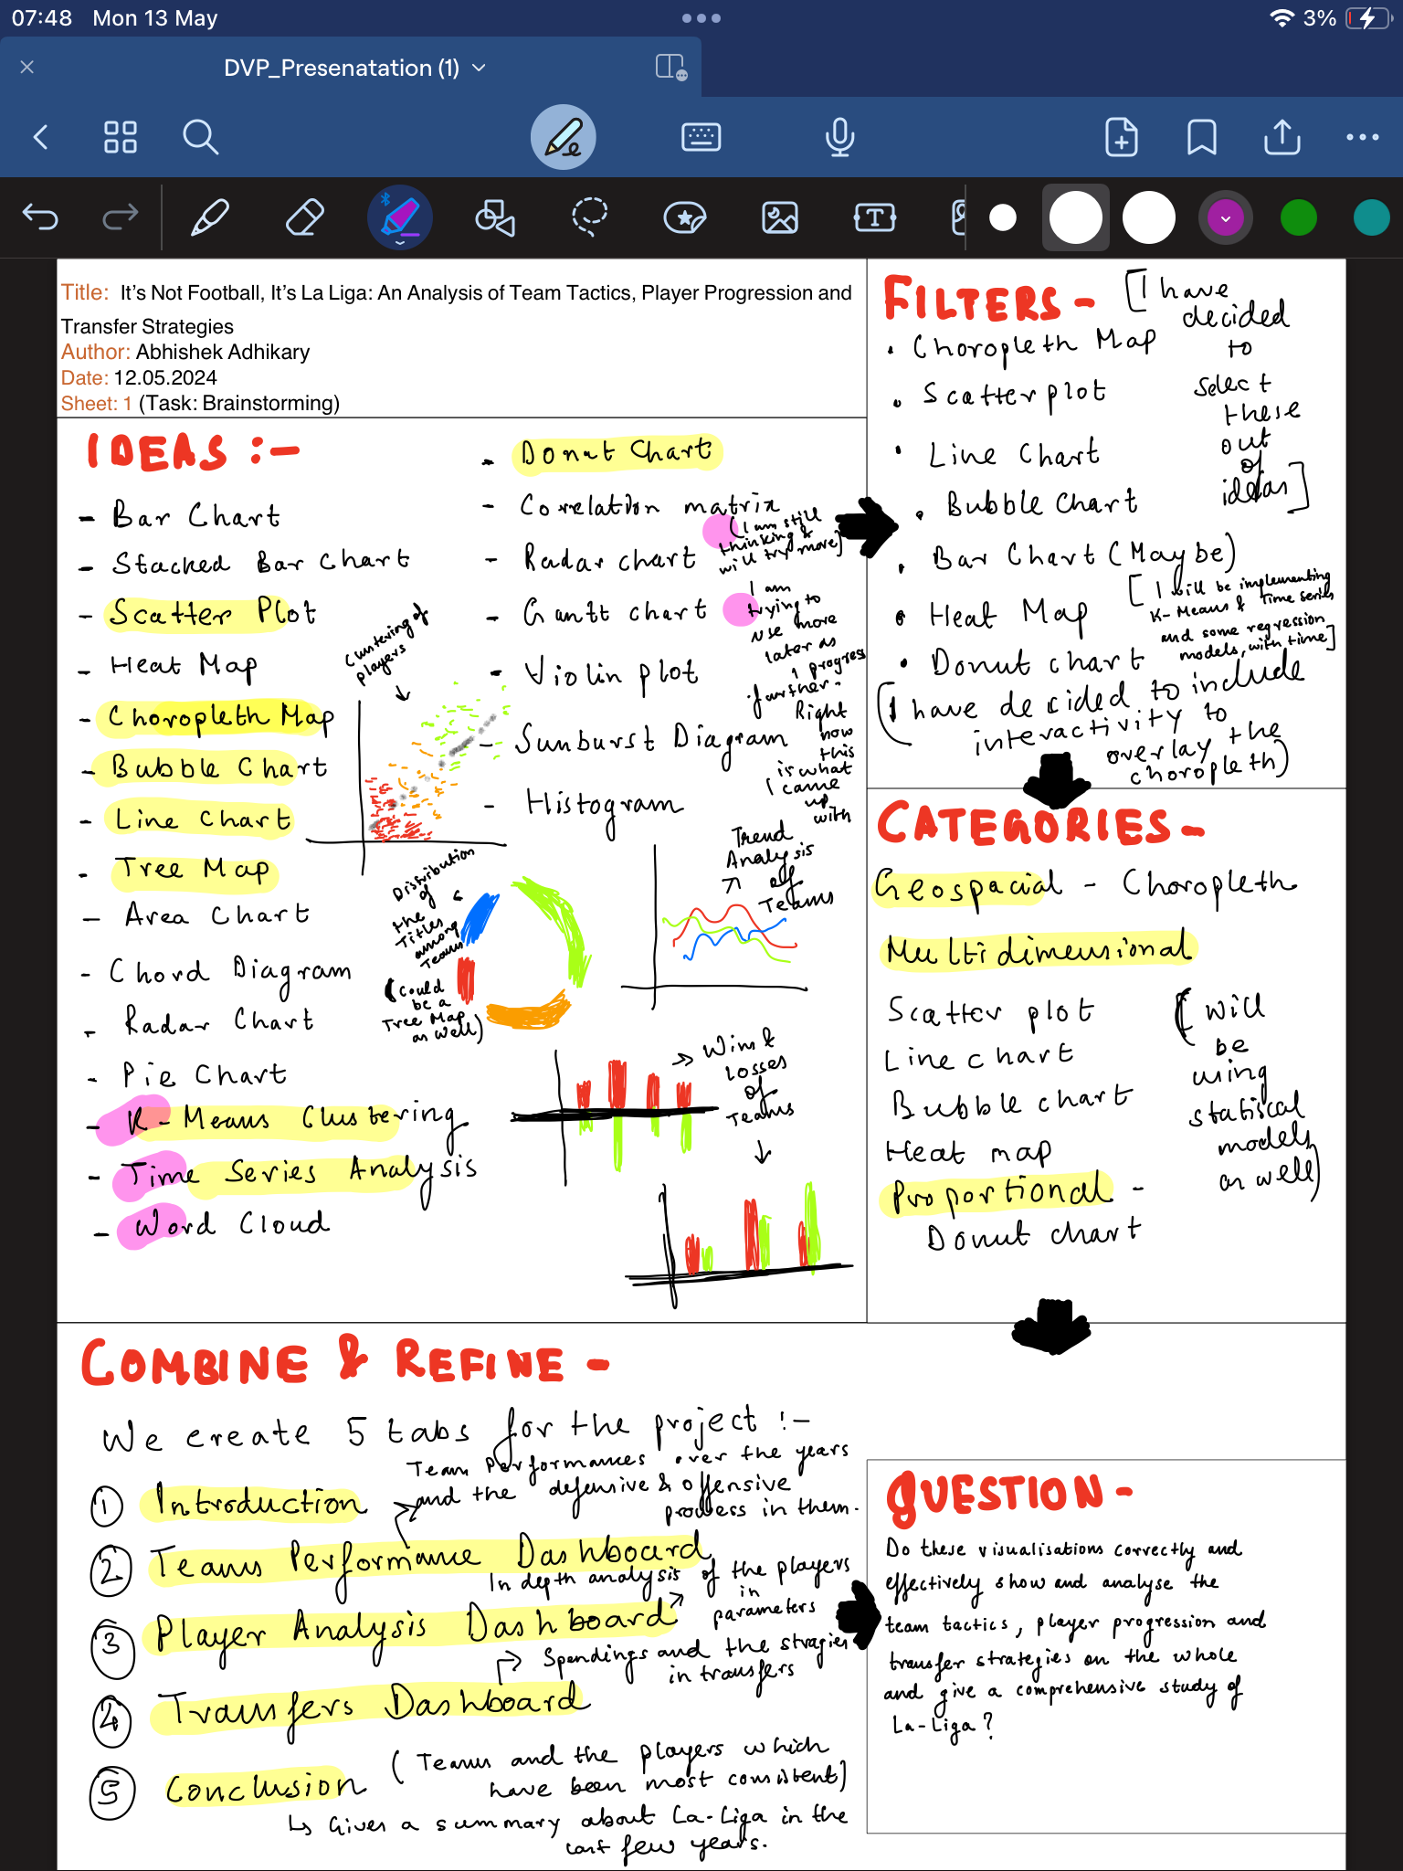

Figure 6.1 Sheet 1(Brainstorming)

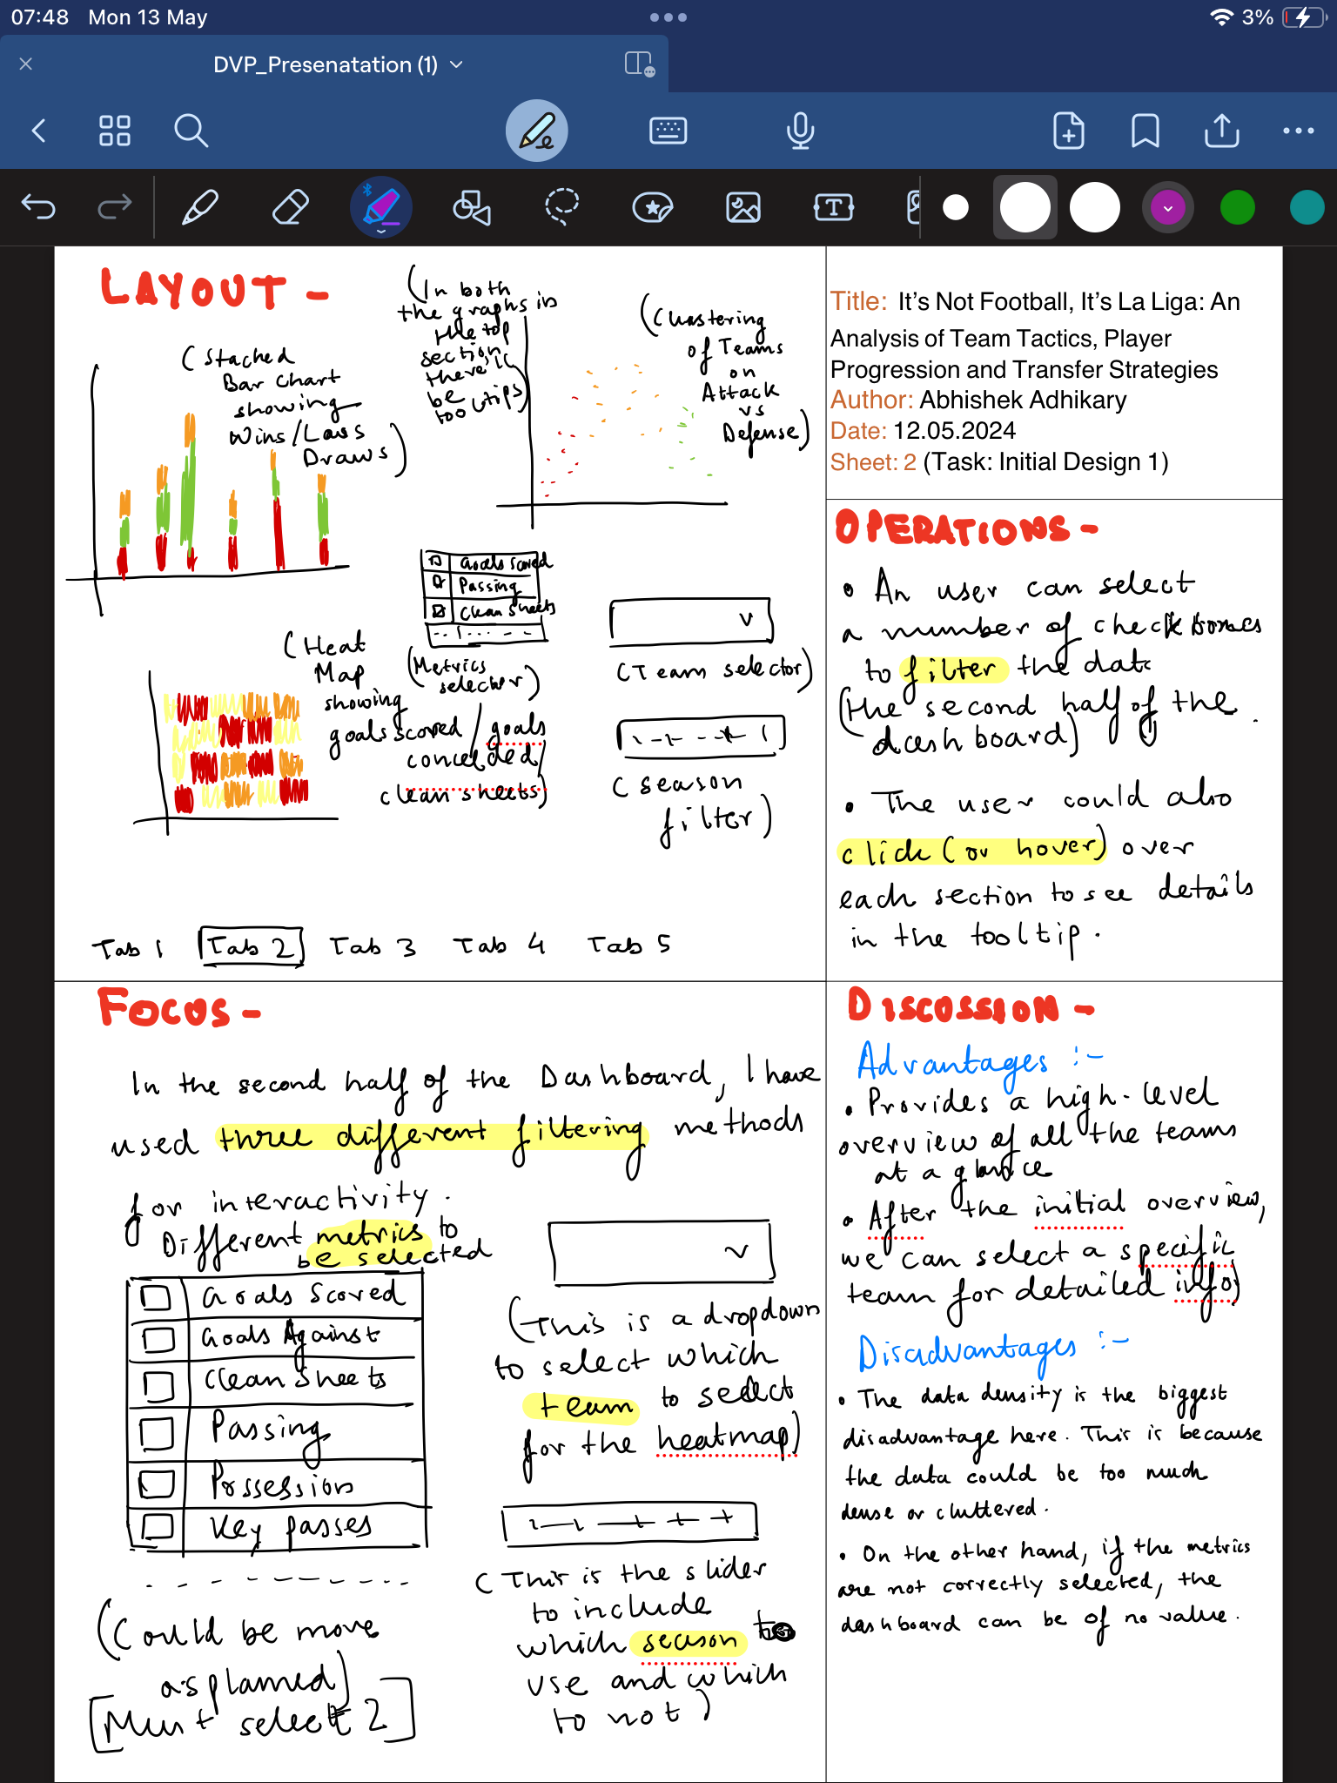

Figure 6.2: Sheet 2(Initial Design 1)

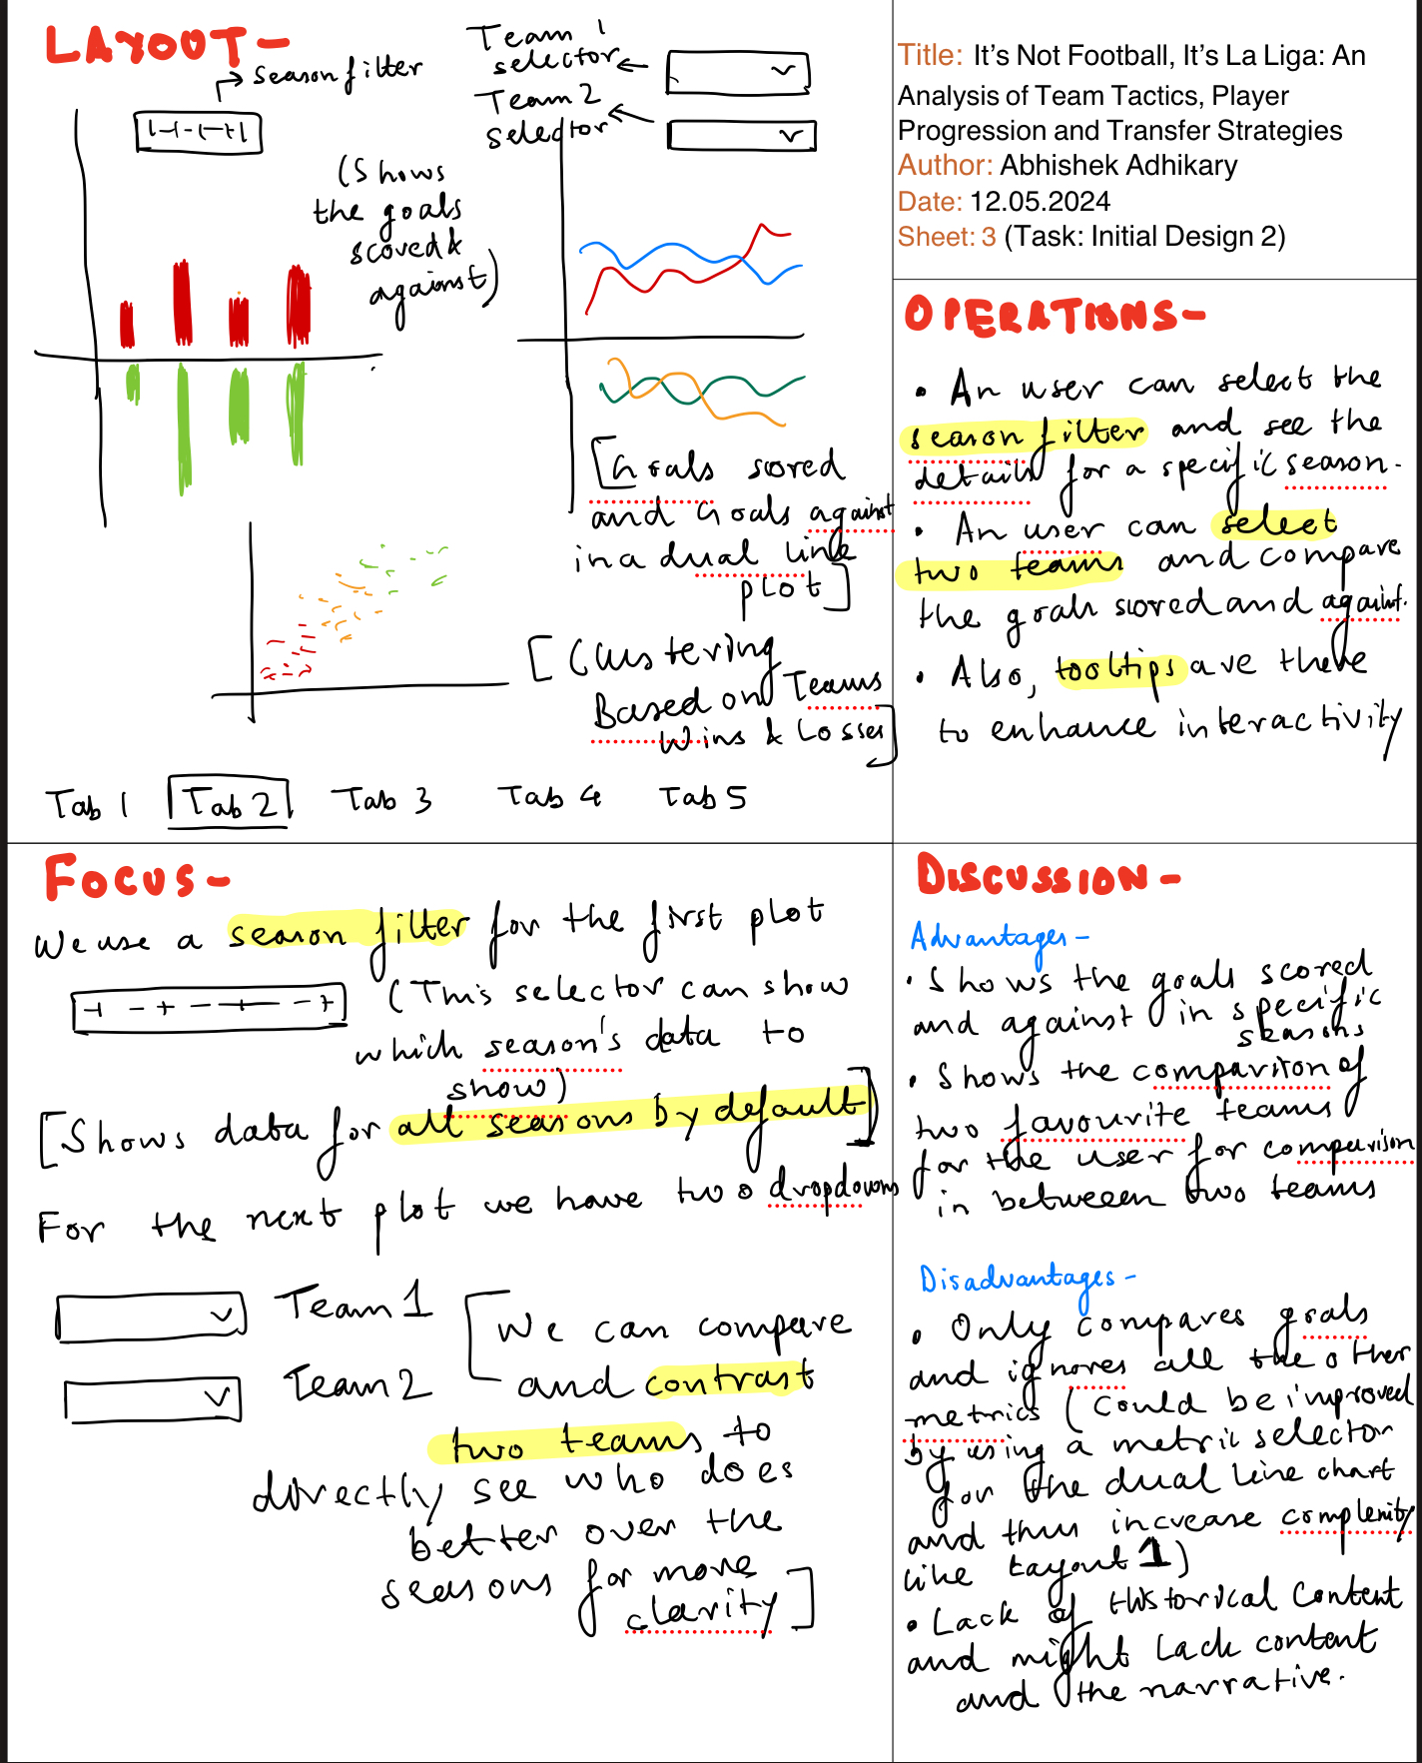

Figure 6.3: Sheet 3(Initial Design 2)

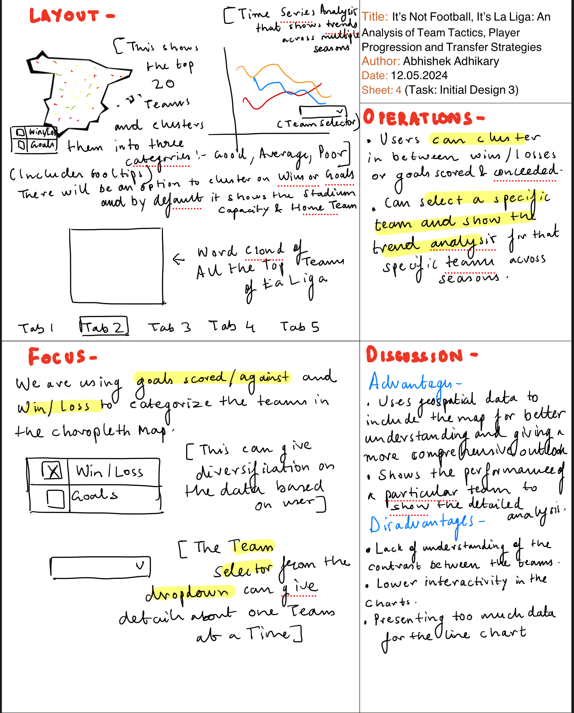

Figure 6.4: Sheet 4 (Initial Design 3)

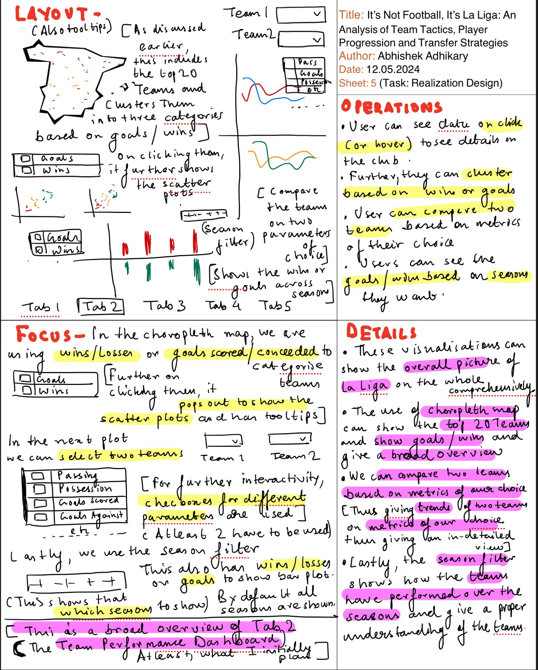

Figure 6.5: Sheet 5 (Realization Design)

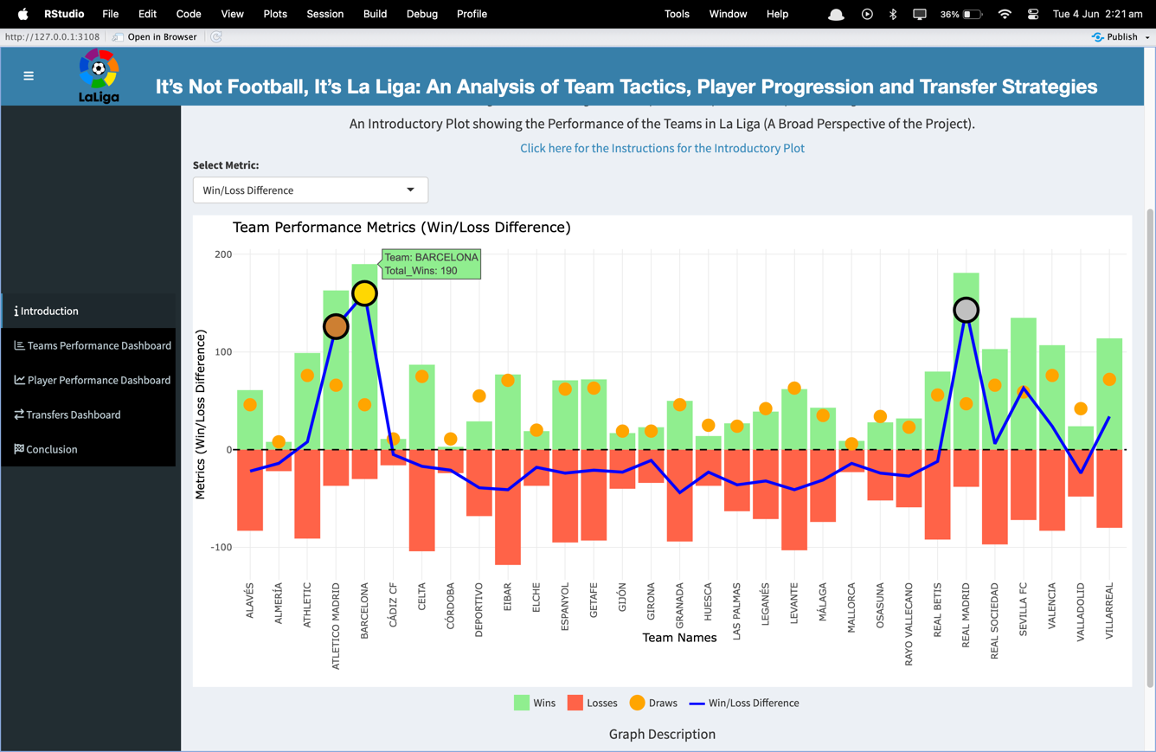

Figure 6.6: Introduction Tab

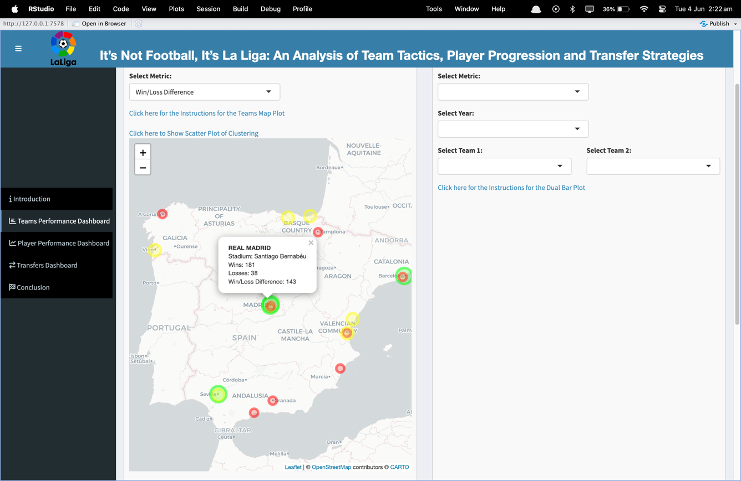

Figure 6.7: Teams Performance Dashboard

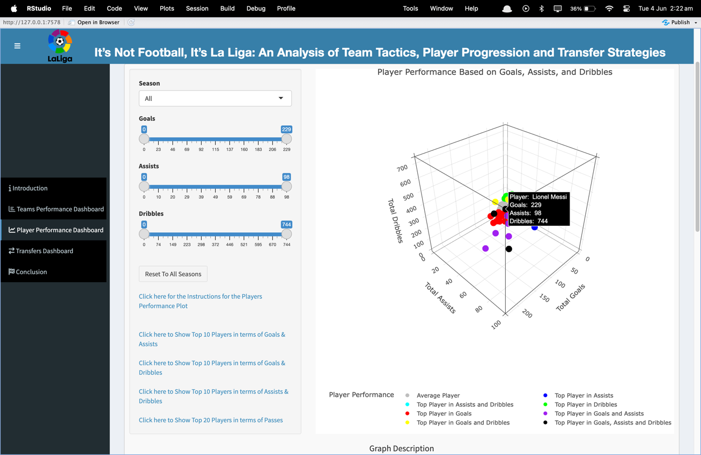

Figure 6.8: Player Performance Dashboard Graph 1

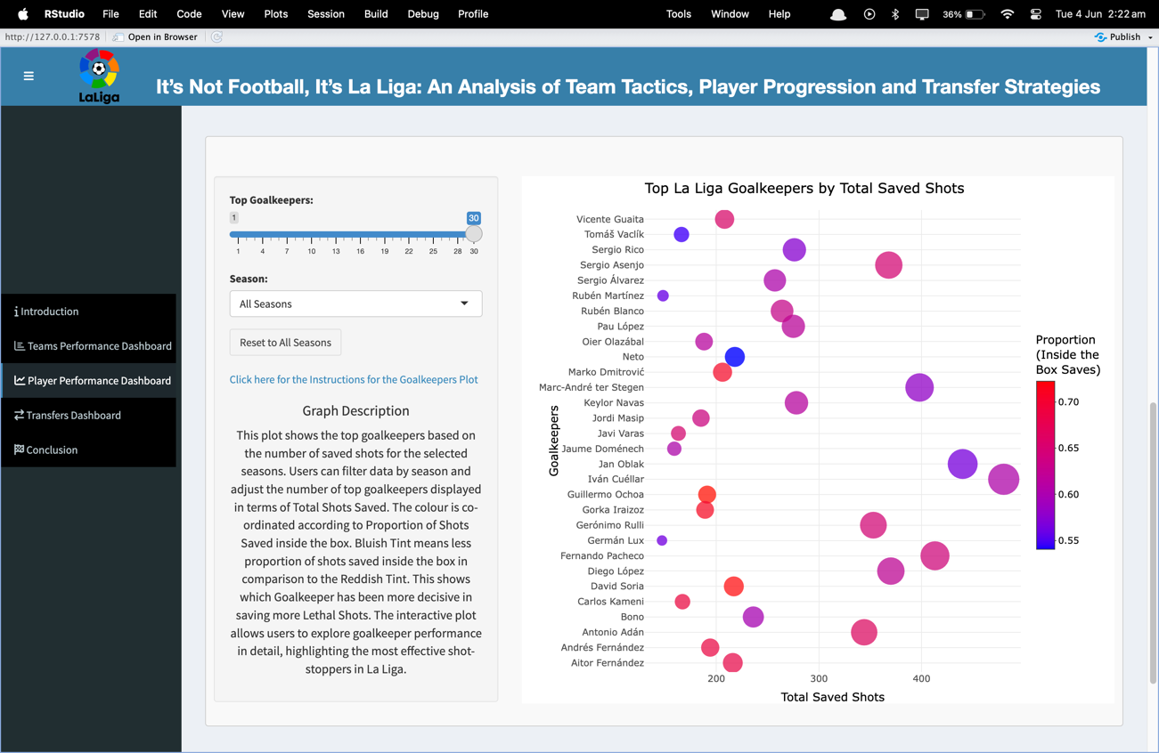

Figure 6.9: Player Performance Dashboard Graph 2

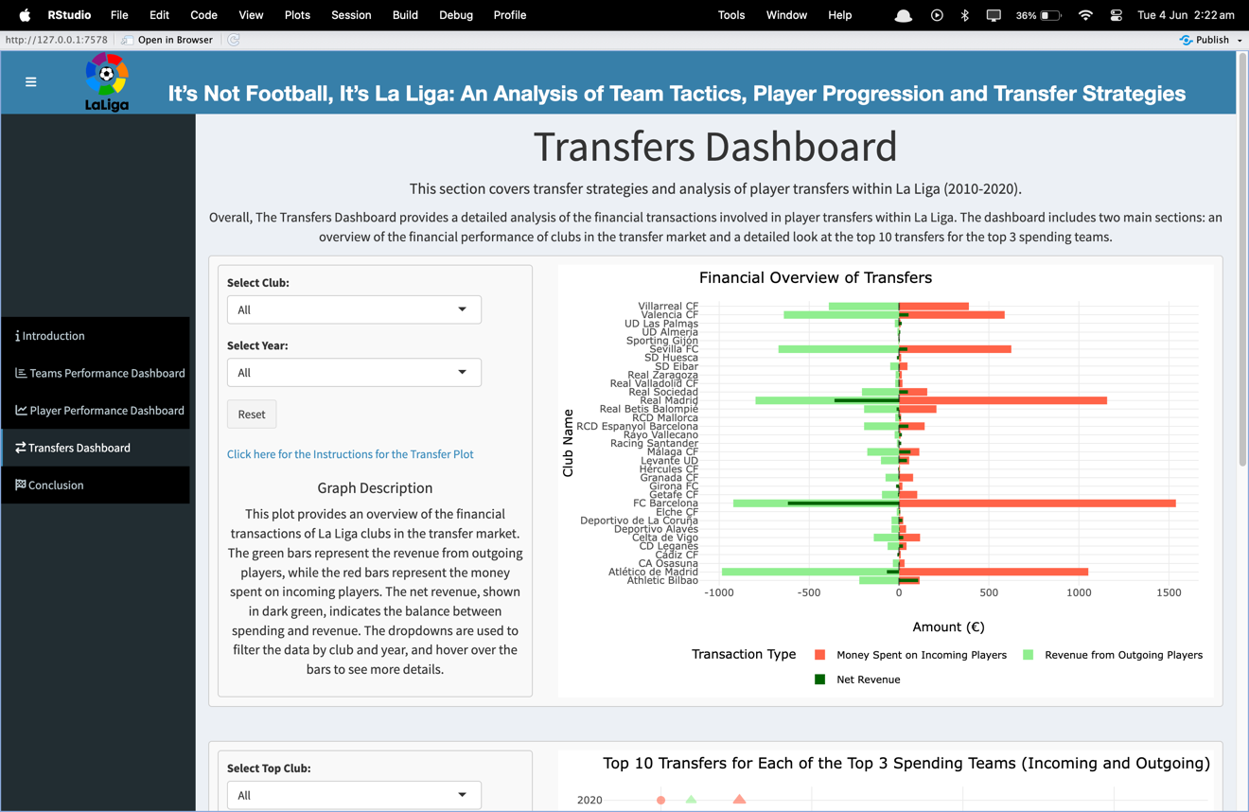

Figure 6.10: Transfers Dashboard Graph 1

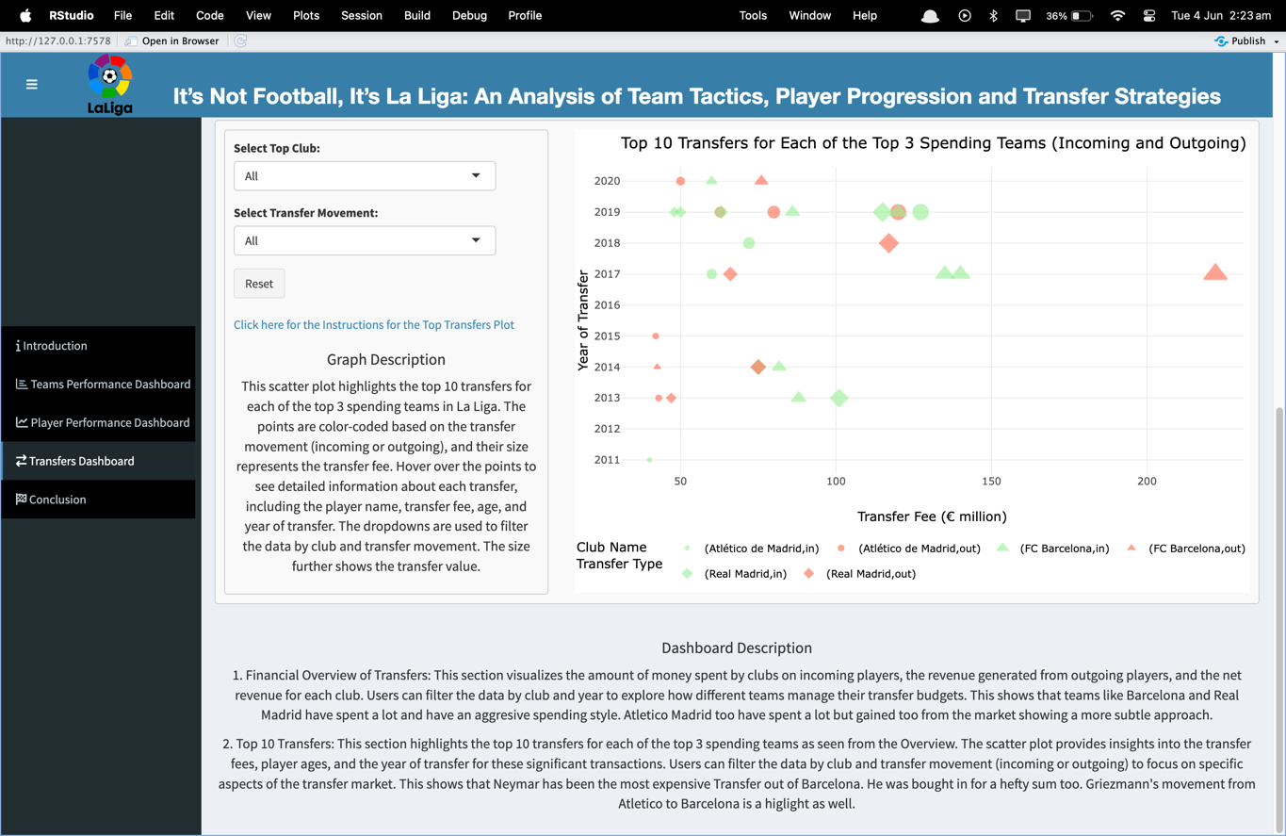

Figure 6.11: Transfer Dashboard Graph 2

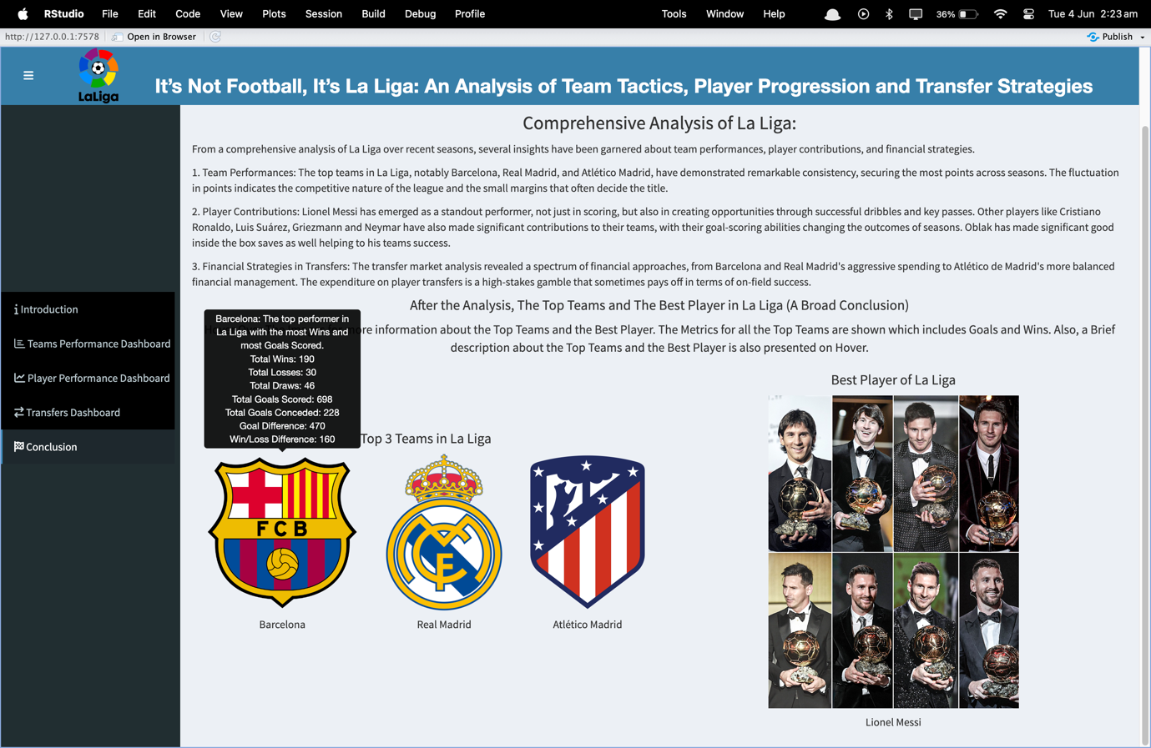

Figure 6.12: Conclusion Tab